Sunday and Wednesday School 2023/2024
This year for our Sunday / Wednesday school curriculum will be using Cokesbury Kids rotation station curriculum for grades PreK-6 th grade as they have easier lessons for younger kids and harder ones for older kids.
The lessons covered this year will be Creation, The Rainbow Promise, Joseph’s Journey, Ten Commandments, and Moses and His Sister.
Creation – Children will hear the story of God's gift of creation and give thanks for the goodness of all God has made!
Bible Story: Genesis 1:1 - 2:4
Sunday, September 17th – Art
Leader: Rachel M.
Helpers: Amanda M. & Stacy S.
5th & 6th Grade: Jolene
Wednesday, September 20th – Art
Sunday, September 24th – Games
Leader: Kris L.
Helpers: Jen S., Kylan, Asher, & Craig O.
5th & 6th Grade: Sarah B.
Wednesday, September 27th – Games
Sunday, October 1st – Food
Leader: Michelle K.
Helpers: Beth O., Katie S. & Stevie O.
5th & 6th Grade: Emma H.
Wednesday, October 4th – Food
Sunday, October 8th – Drama
Leader: Jen S.
Helpers: Lindsey B. & Ashley B.
5th & 6th Grade: Jolene
Wednesday, October 11th - Drama
The Rainbow Promise – Children will hear the story of God's covenant with Noah and learn that we can trust God.
Bible Story: Genesis 6:13-22; 7:1-16; 8:1-9:17
Sunday, October 15th – Art
Leader: Rachel M.
Helpers: Amanda M. & Stacy S.
5th & 6th Grade: Sarah B.
Wednesday, October 18th – Art
Sunday, October 22nd - Games
Leader: Kris L.
Helpers: Jen S., Kylan, Asher, & Craig O.
5th & 6th Grade: Emma H.
Wednesday, October 25th – Fall Festival
Sunday, October 29th - Confirmation Sunday – no Sunday School
Wednesday, November 1st – Service Project
Sunday, November 5th – Food
Leader: Michelle K.
Helpers: Beth O., Katie S. & Stevie O.
5th & 6th Grade: Jolene S.
Wednesday, November 8th - Food
Sunday, November 12th – Practice Christmas Program
Wednesday, November 15th – Practice Christmas Program
Sunday, November 19th – Practice Christmas Program
Wednesday, November 22th – Thanksgiving Break No Class
Sunday, November 26th – Thanksgiving Break – No Class
Wednesday, November 29th – Practice Christmas Program
Sunday, December 3rd – Practice Christmas Program
Wednesday, December 6th – Practice Christmas Program
Sunday, December 10th – Practice Christmas Program
Wednesday, December 13th – Practice Christmas Program
Sunday, December 17th – Christmas Program & Gingerbread Manger Scene
Wednesday, December 20th – Christmas Program & Gingerbread Manger Scene
Sunday, December 24th – Christmas Eve
Wednesday, December 27th – Christmas Break – No Class
Sunday, December 31st – Christmas Break – No Class
Joseph’s Journey – Children will hear the story of Joseph.
Bible Story: Genesis 37, 39-46
Wednesday, January 3rd – Art
Sunday, January 7th – Art
Leader: Rachel M.
Helpers: Amanda M. & Stacy S.
5th & 6th Grade: Sarah B.
Wednesday, January 10th – Games
Sunday, January 14th – Games
Leader: Kris L.
Helpers: Jen S., Kylan, Asher, & Craig O.
5th & 6th Grade: Emma H.
Wednesday, January 17th – Food
Sunday, January 21st – Food
Leader: Michelle K.
Helpers: Beth O., Katie S. & Stevie O.
5th & 6th Grade: Jolene S.
Wednesday, January 24th – Drama
Sunday, January 28th – Drama
Leader: Jen S.
Helpers: Lindsey B. & Ashley B.
5th & 6th Grade: Sarah B.
The Ten Commandments – Children will hear the story of the Israelites receiving the Ten Commandments.
Bible Story: Exodus 3:7-10; 5:1-2; 6:1-10; 12:31-15:21
Wednesday, January 31st – Art
Sunday, February 4th – Art
Leader: Rachel M.
Helpers: Amanda M. & Stacy S.
5th & 6th Grade: Emma H.
Wednesday, February 7th – Games
Sunday, February 11th – Games
Leader: Kris L.
Helpers: Jen S., Kylan, Asher, & Craig O.
5th & 6th Grade: Jolene S.
Wednesday, February 14th – Ash Wednesday
Sunday, February 18th – No Class School Break
Wednesday, February 21st – Lenten Activities
Sunday, February 25th – Lenten Activities
Wednesday, February 28th – Lenten Activities
Sunday, March 3rd – Lenten Activities
Wednesday, March 6th – Lenten Activities
Sunday, March 10th – Lenten Activities
Wednesday, March 13th – No Wednesday School Spring Break
Sunday, March 17th – No Sunday School Spring Break
Wednesday, March 20nd – Lenten Activities
Sunday, March 24th – Palm Sunday
Wednesday March 27th – No Class Holy Week
Thursday, March 28th – Maundy Thursday
Friday, March 29th - Good Friday
Sunday, March 31st – Easter Sunday
Wednesday, April 3rd – No Class Easter Break
Sunday, April 7th – Food
Leader: Michelle K.
Helpers: Beth O., Katie S. & Stevie O.
5th & 6th Grade: Sarah B.
Wednesday, April 10th – Food
Sunday, April 14th – Drama
Leader: Jen S.
Helpers: Lindsey B. & Ashley B.
5th & 6th Grade: Emma H.
Wednesday, April 17th - Drama
Moses and His Sister – Children will hear the story of Moses's birth and learn how his family looked after him so that he could grow up safely and one day lead the Hebrews to the Promised Land.
Bible Story: Exodus 1:8 - 2:10
Sunday, April 21st – Art
Leader: Rachel M.
Helpers: Amanda M. & Stacy S.
5th & 6th Grade: Jolene S.
Wednesday, April 24th - Art
Sunday, April 28th – Games
Leader: Kris L.
Helpers: Jen S., Kylan, Asher, & Craig O.
5th & 6th Grade: Sarah B.
Wednesday, May 1st - Games
Sunday, May 5th – Last Day of Class
5th & 6th Grade teachers can decide what they want to do.
Wednesday, May 8th – Last Day of Class
Sunday, May 12th – Spring Picnic & Mother’s Day
Wednesday, May 15th – Spring Picnic
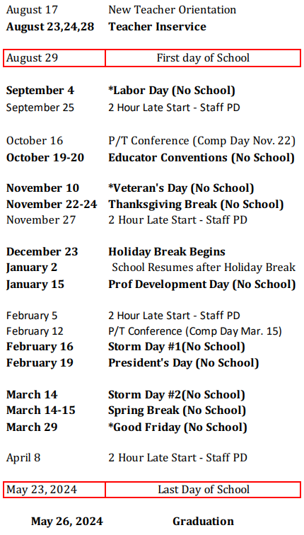
Norman Lutheran Sunday school will start Sunday, September 17^{th,} and will be during the worship hour. Families will start together, and children will go down to class following the children’s moment.Davenport Lutheran Wednesday Kids Club will start September 20th and will meet from 4:15 pm – 5:00 pm. If you would like to teach Sunday or Wednesday School, please contact Pastor Katie @pastorkatiend@gmail.com
Confirmation will meet at Norman Lutheran Church on Wednesdays. 7th & 8th grade from 6:30 pm – 7:15 pm and 9th grade from 7:30 – 8:15 p.m. starting September 20th.

